**TITLE: STUDENT MANAGEMENT SYSTEM**

*A Thesis of Experiential Learning*

*Submitted in partial fulfilment of the requirements for the degree of B.Tech. in* ***CSE***

CRANES VARSITY “C PROGRAMMING” EXPERIENTIAL LEANNING

|  |  |  |
| --- | --- | --- |
| **NAME** | **CRANES REGD. NO.** | **Regd. No.** |
| CHANDAN CHOUDHURY | CL2025010601911046 | 2201020352 |
| ADITYA NAYAK | CL2025010601911349 | 2201020377 |
| SANJEEB KUMAR POTHAL | CL2025010601938185 | 2201020411 |
| GYANA RANJAN SAHOO | CL20250106019414118 | 2201020033 |

Under The Supervision Of: Mr. Anurag Rajput

Dept. of CSE C.V. Raman Global University, Odisha



DEPARTMENT OF COMPUTER SCIENCE AND ENGINEERING

**C. V. Raman Global University, Odisha, Bhubaneswar**

PIN -752054, India

**ACKNOWLEDGEMENT**

We would like to express our sincere gratitude to all those who have supported us throughout the completion of this project report on " STUDENT MANAGEMENT SYSTEM". We would like to extend our heartfelt thanks to our [Project Guide/Advisor] “**Mr. Anurag Rajput**” for providing invaluable guidance, support, and encouragement throughout the project. His expertise and knowledge have been instrumental in shaping this report. Lastly, we would like to acknowledge the contributions of all the individuals and organizations whose research and work have been referenced in this report.

Lastly, we acknowledge the contribution of various online resources, documentation, and open-source libraries that aided in the successful implementation of the project.

**Team Members:**

* **Chandan Choudhury** (CRANES Regd. No. CL2025010601911046), 2201020352
* **Sanjeeb Kumar Pothal** (CRANES Regd. No. CL2025010601938185), 2201020411
* **Aditya Nayak** (CRANES Regd. No. CL2025010601911349), 2201020377
* **Gyana Ranjan Sahoo** (CRANES Regd. No. CL20250106019414118), 2201020033

We sincerely hope that our project will prove beneficial for future studies and inspire others to explore similar technological solutions.

**Thank you.**

**TABLE OF CONTENTS**

1. Abstract
2. Aim of the Project
3. Introduction
4. Key Features of Student Database Management System
5. Benefits of Using Student Database Management System
6. Technology Used in Student Database Management System
7. Background Information on Student Database Management
8. Future Enhancements of the Student Database Management System
9. Output
10. Conclusion
11. References

**ABSTRACT**

Managing student records is a fundamental task in educational institutions. A Student Database Management System (SDMS) is designed to digitize and streamline the process of maintaining student records efficiently. The system enables accurate data storage, retrieval, and modification of student details, including personal information, academic performance, attendance, and fee management.

Traditionally, student records were managed manually using paper files or spreadsheets, which were prone to errors, inefficiencies, and loss of information. The SDMS, developed in C programming language, provides a structured, automated, and secure approach to handling student data. By implementing file handling techniques, the system ensures data persistence and allows users to add, update, delete, and search for student records efficiently.

This project is essential for educational institutions looking to reduce administrative workload, improve data security, and enhance decision-making through a digital database system. The C language, being lightweight and highly efficient, ensures quick processing, optimized memory usage, and reliability in handling student records.

**Aim Of The Project**

The aim of this project is to design and implement a digital student database management system that efficiently organizes, maintains, and safeguards student records. The project focuses on achieving the following key objectives:

1. **Digitizing Student Records**: The system will replace paper-based methods by offering a reliable digital platform for storing student information. This reduces dependency on physical documents and enhances operational efficiency.
2. **Ensuring Data Accuracy**: By automating the processes of record keeping and retrieval, the system will reduce human errors associated with manual data entry and ensure consistent, error-free management of student records.
3. **Strengthening Data Security**: The system will feature robust mechanisms to protect sensitive student data against unauthorized access and accidental loss. This includes implementing encryption, user authentication, and access control measures.
4. **Improving Data Accessibility**: Administrators and faculty will benefit from the ability to quickly locate and retrieve detailed student information. This will streamline routine tasks like student profiling or academic tracking.
5. **Providing an Intuitive User Interface**: The software will be designed to be straightforward and user-friendly, making it accessible even to staff members who may have limited technical expertise.
6. **Eliminating Redundancy**: By detecting and preventing duplicate entries, the system will enhance the efficiency of data storage and minimize unnecessary repetitions.

Through the implementation of this digital solution, educational institutions can significantly improve their record-keeping practices. They will be able to reduce paperwork, minimize time spent on administrative tasks, and ensure the integrity and security of student data.

**Introduction**

Managing student data is a vital task for any educational institution, as it directly influences both academic and administrative operations. Student records typically include personal information, enrollment data, course registrations, grades, attendance, disciplinary history, and financial details like fees and scholarships. Traditional methods of handling such records, which depend on physical files, paper-based documentation, or spreadsheets, often lead to inefficiencies, errors, redundant data, and the risk of data loss due to damage or misplacement. These manual processes are not only time-consuming but also prone to human error, making it challenging to retrieve information when required.

A Student Database Management System (SDMS) is designed to address these challenges by offering a systematic, automated, and accurate solution for managing student records. This system, developed using the C programming language, employs file-handling techniques to ensure that student data is stored securely, accessed easily, and managed efficiently. By reducing administrative workload, the SDMS allows for quick retrieval of information while also enhancing data security through measures that prevent unauthorized access and accidental loss.

As educational institutions witness growing enrollments, manual record-keeping becomes increasingly impractical. The SDMS serves as a reliable tool to improve data accuracy, streamline administrative processes, and comply with institutional policies. By replacing outdated manual methods, this system offers a modern and efficient approach to student data management, making it indispensable for schools, colleges, and universities.

**Key Features Of Student Database Management System**

The Student Database Management System offers several key functionalities to simplify record management and enhance operational efficiency:

**1. Student Registration & Record Management**

o Allows adding, modifying, deleting, and viewing student records.

o Stores essential student information such as name, roll number, date of

birth, contact details, and course details.

o Uses structured file handling to ensure persistent data storage.

**2. Academic Performance Tracking**

o Maintains student exam scores, grades, and overall performance records.

o Provides easy retrieval and modification of academic records.

3. Attendance Management

o Tracks student attendance in different subjects.

o Helps in monitoring student participation and generating attendance

reports.

**5. Search & Filtering Options**

o Allows searching for student records using name, roll number, department,

or year of study.

o Provides sorted views for better organization.

**6. Data Security & Backup**

o Provides backup and restore functionality to prevent data loss.

**Benefits Of Using Student Database Management System**

The adoption of a Student Database Management System (SDMS) brings numerous benefits to educational institutions, supporting administrators, faculty, and students alike. Some of the primary advantages are as follows:

1. Streamlined Data Organization Traditional methods of record-keeping can be tedious and unorganized. The SDMS simplifies and automates the management of student data, ensuring swift and systematic access to information.
2. Greater Accuracy and Reduced Errors Manual data processing is susceptible to errors and inconsistencies. The SDMS ensures precision by offering a well-structured digital system for inputting and maintaining student records.
3. Increased Efficiency Administrative tasks become significantly faster, as the SDMS facilitates quick retrieval, updating, and modification of records, thereby cutting down on paperwork and expediting institutional operations.
4. Secure Data Protection Sensitive student information is safeguarded through robust security measures, including access controls, to ensure that only authorized individuals can access or modify the data.
5. Data-Driven Insights With access to organized information on academic performance, attendance, and financial records, institutions can make better decisions and implement strategies for improvement.
6. Ease of Use The SDMS is equipped with an intuitive, text-based interface, making it accessible to faculty and administrators, even those without extensive technical skills.

**Technology Used In Student Database Management System**

Programming Language: C

* Ensures high-speed execution and efficient use of memory resources.
* Provides robust file-handling capabilities for seamless database management.

Database Management: File Handling in C

* Utilizes text files (.txt) and binary files (.dat) to store and retrieve student records.
* Adopts structured storage techniques to safeguard data from loss.

User Interface: Command-Line Interface (CLI)

* Features a straightforward, text-based, menu-driven design for effortless navigation.

Data Structures Employed:

* Incorporates arrays, structures, and linked lists to efficiently organize and manage student data.

**Background Information On The Student Database**

As educational institutions grow and student enrollments increase, traditional methods of manual record-keeping are proving to be outdated and inefficient. Historically, institutions have relied on physical registers, spreadsheets, or standalone software to manage student information. However, these conventional practices present several drawbacks, such as:

* Data Redundancy and Inconsistencies: Manual entries often result in duplicated records and conflicting information.
* Challenges in Record Retrieval: Searching for specific student details in physical files or spreadsheets is both time-intensive and inefficient.
* Risk of Physical Document Loss or Damage: Paper-based records are prone to wear and tear, misplacement, or accidental destruction.
* Inadequate Security Measures: Traditional systems lack advanced access control mechanisms, making student data vulnerable to unauthorized access or breaches.

To address these issues, a Student Database Management System (SDMS) provides a robust digital alternative. The SDMS introduces structured data storage, allows instant access to records, and incorporates stronger security features. By automating the management of student data, the SDMS minimizes human error, enhances accessibility, and preserves the accuracy and integrity of information. Moreover, it effectively handles large volumes of student records, making it an essential tool for modern educational institutions aiming to streamline their operations, bolster security, and boost overall efficiency.

**Future Enhancements**

As technology advances, there is considerable potential to elevate the functionality, security, and overall efficiency of the Student Database Management System (SDMS). Some of the most promising enhancements for the future are:

1. Incorporation of a Graphical User Interface (GUI) The existing command-line interface may not be ideal for users with limited technical expertise. Developing a GUI using frameworks such as GTK, Qt, or JavaFX would enhance user experience, making the system more intuitive and accessible for administrators, faculty, and students.
2. Integration with Structured Database Systems (SQL) Shifting from file-based data storage to a database management system like MySQL, PostgreSQL, or SQLite would improve data security, optimize record retrieval, and facilitate efficient handling of larger datasets. This upgrade would also eliminate redundancy and maintain better data consistency.
3. Cloud-Based Storage Solutions By adopting cloud storage, educational institutions can enable authorized users to access student information remotely, streamlining administrative tasks and online record management. Cloud systems also provide reliable backup options and disaster recovery mechanisms in case of technical failures.
4. Role-Based Access Control (RBAC) Adding multi-tiered access controls would allow different user roles—administrators, teachers, students, or parents—to access only the data relevant to their permissions, thereby safeguarding sensitive student records from unauthorized changes.
5. Automated Notifications and Reporting Enhancing the system to generate automatic reports, academic transcripts, fee reminders, or attendance updates via email or SMS would improve communication and coordination between students, faculty, and administrators.
6. Artificial Intelligence for Analytics Incorporating AI-driven tools could enable institutions to analyze student academic performance, attendance records, and behavioral patterns. Machine learning models could predict trends and provide personalized recommendations for improvement.
7. Biometric Authentication For institutions requiring heightened security, implementing biometric authentication methods—such as fingerprint or facial recognition—would ensure secure user login and prevent unauthorized access.
8. Mobile Application Development Creating a mobile-friendly version of the SDMS would allow stakeholders to conveniently access academic records, attendance updates, fee payment portals, and institutional announcements on their smartphones.

By integrating these enhancements, the SDMS can transform into a more sophisticated, secure, and user-centric platform that meets the evolving needs of educational institutions. Such improvements would boost operational efficiency, strengthen data security, and facilitate seamless administrative processes.

**Sample Outputs**

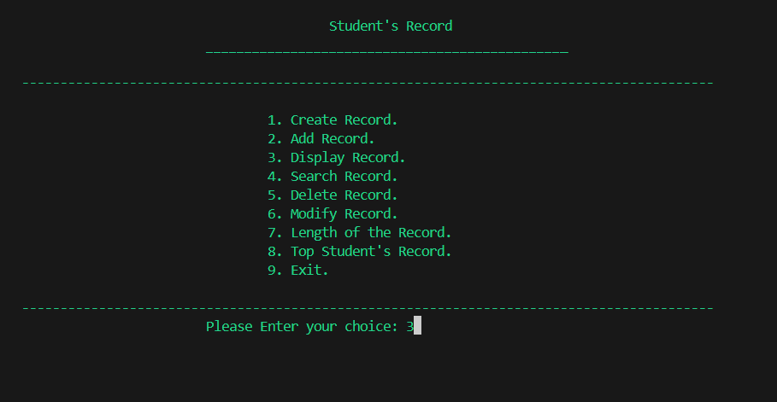

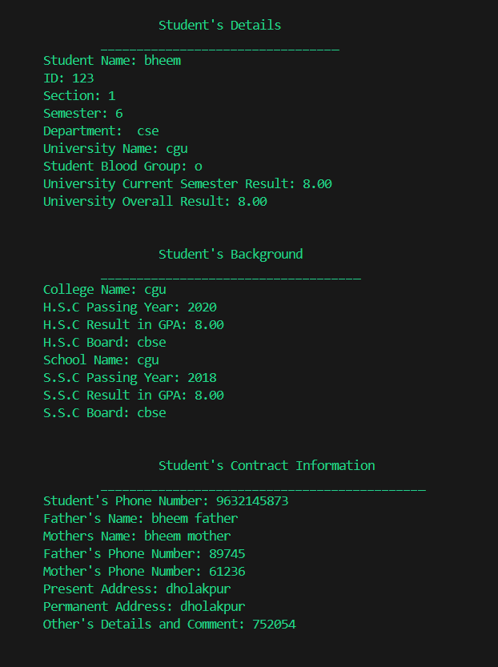

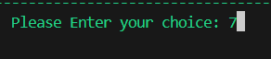

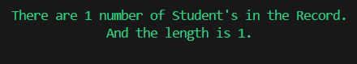

**CONCLUSION**

The Student Database Management System (SDMS) represents a significant breakthrough for educational institutions, addressing the longstanding challenges of managing student records in a secure, efficient, and organized manner. Traditional methods of record-keeping, such as physical registers, spreadsheets, and standalone software, often fall short due to their susceptibility to errors, mismanagement, and inefficiencies. These systems are increasingly impractical in the face of growing student enrollments and expanding institutional needs, making the transition to digital solutions not just desirable but imperative.

The SDMS utilizes the powerful capabilities of C programming and file handling techniques to provide a structured framework for storing, retrieving, and maintaining student data. By leveraging optimized memory usage and efficient execution speed, the system ensures fast and reliable access to records while preserving data accuracy. The use of structured file handling mechanisms enables persistent data storage, ensuring that information is securely stored and readily available for retrieval whenever needed.

One of the core strengths of the SDMS lies in its ability to automate critical processes, such as data entry, modification, and retrieval. These automated functionalities minimize the need for manual intervention, thereby reducing workload for administrative staff and significantly lowering the risk of human errors. The system also addresses the common issue of data redundancy by implementing mechanisms to eliminate duplicate entries, leading to more efficient data management and streamlined operations.

Security and data integrity are paramount in the SDMS. The system incorporates robust features, such as access control mechanisms, to ensure that only authorized personnel can view or modify sensitive student information. Backup functionality provides an additional layer of protection, safeguarding records against accidental loss or corruption. These measures collectively create a secure environment for managing student data while maintaining the highest standards of confidentiality and integrity.

Beyond its technical capabilities, the SDMS delivers measurable benefits to educational institutions by improving operational efficiency and enabling better decision-making. Administrators can effortlessly access and analyze student information, such as academic performance, attendance trends, and fee records, to make informed decisions and implement improvements. The system also supports compliance with institutional policies and enhances transparency in data management.

In an era where the demands on educational institutions continue to grow, the SDMS emerges as an indispensable tool. Its ability to handle large volumes of data with speed, accuracy, and security makes it a valuable asset for schools, colleges, and universities striving to modernize their administrative processes. By adopting the SDMS, institutions can not only reduce paperwork and manual effort but also foster a more reliable and secure approach to managing student records.

**REFERENCES**

A. Silberschatz, H. F. Korth, S. Sudarshan, Database System Concepts,

McGraw-Hill, 6th Edition, 2019.

• A comprehensive book covering database management systems and

data storage techniques.

Dennis M. Ritchie & Brian W. Kernighan, The C Programming Language,

Prentice Hall, 2nd Edition, 1988.

• A fundamental resource for learning C programming and file handling

techniques.

Ramakrishnan R., Gehrke J., Database Management Systems, McGraw-Hill,

3rd Edition, 2003.

• Covers fundamental concepts related to database management,

indexing, and security.

Elmasri, R. & Navathe, S. B., Fundamentals of Database Systems, Pearson

Education, 7th Edition, 2016.

Web Resource: "Introduction to File Handling in C" - GeeksforGeeks

• Online resource explaining file handling operations in C programming.

Web Resource: "Student Database Management System in C – A Complete

Guide" - TutorialsPoint

• Provides an overview of implementing a student database

management system using C.